Design documentation:
Working title
Features:
Parallax background’s
Character movement
Collectables
Music
Sound effects
Ui
Controller capabilities
Stretch features:
Powerups
Procedural generation

Concept 1: surely you joust
Genre: medieval slapstick
Story/setup:
A new gnome jousting tournament has been announced, and the player is placed into the role of sir gnomish a proud gnome (working name) looking to make gnomish (working name) name famous, join him in his journey to become top jouster against sir stink feet, (working name) lord bucket head (working name) and the infamous black gnome-knight.
Features:
The player has to mash the space key to increase their speed and momentum whilst keeping your mouse steady in the centre of the target to defeat your opponent. The player gets their score from the momentum value and their (how many times they’ve pressed the button) accuracy value (how close the mouse is to the centre), each opponent will have 3 lives alongside the player, and each match goes on till either side is left with 0 lives, the players live are carried over through each match. In between match’s you can spend your score to increase your accuracy (mouse pull), power (increase momentum gained per press) alongside life’s, these would be represented by tents the player can move between.
Art direction
The graphical style will be 2.5d using 3d assets instead of pixel assets.
Mood board:
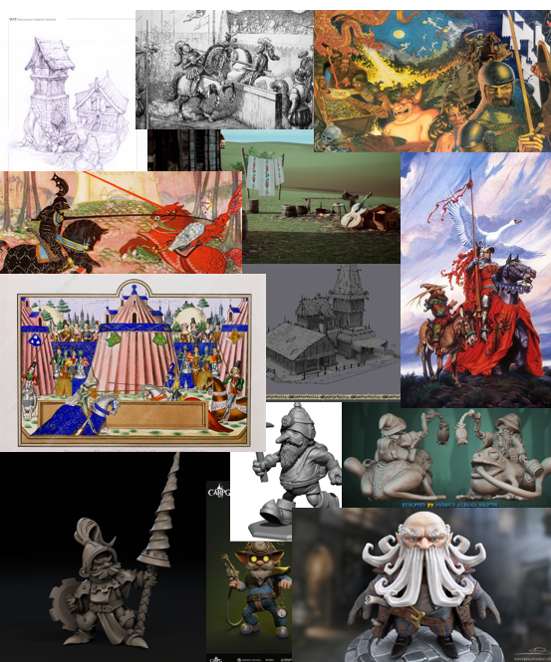
strength:
covers all the features needed with room to grow and fulfils extra or stretch goals.
The concept allows for a lot of stylizations.
The project flexibility allows for cutbacks to be made if development time is running low or a feature is taking too long to implement.
Simple controls allowing for ease of adaptability to other control schemes, which would allow it be controller friendly for multiple devices and models from phone to switch.
The art style allows for a quicker workflow due to my skills in 3d being better than my 2d skills.
Theirs a lot of adjustability with the concept within length as opponent count can be easily changed with little to no impact within the development cycle.
The project has a strong vision which should help speed up early development leading to more development time to be spent on asset production and programming
Weakness:
Lack of depth within controls
Lack of a serious theming could hurt the project
The 2.5d style could end up a problematic feature due to its investment needed in early within production, as if I switch to 2d due to difficulty, implementing it could mean that development time would be reduced along with any asset for the art style.
the rigging process may put too much strain within the production due to amount of character models leading to an unfinished project
character models might take too long to produce to a satisfactory level if a more realistic style is chosen.

Opportunities:
Roguelike elements: this would fulfil the stretch goal and would add increased replay-ability to the title along with a very easy way to add further features through more complex upgrades, this would be implemented by replacing the 2 upgrade tents into 2 random upgrade tents that choose a random effect e.g. strength or accuracy then roll a number generator to decide the rarity e.g. common, rare, masterwork which would then choose from a different number generator to decide the percentage e.g. 20-30.
Gear: this feature could add further depth to the concept with not only cosmetically changes but collision and hit box, along with special effects to add more replay ability, this could be easily implemented along with the score system or as an extra setup menu when starting the game e.g. after the title menu decide between 3 different hats.

Threats:
Due to my personal bias towards the concept I could very easily snowball within production and fail to deliver a project that fulfils the briefs properly leading to an inadequate product.
The production may fall behind due to improper time usage within the production cycle leading to a less idealised product or an unfinished product.
The strong vision may overcloud development time with more artistic features being developed, leaving core game features sidetracked and not left enough development time.
Evaluation:
The concept has a unique concept along side a strong vision but could end up veering away from the brief and have many problem within development due to inexperience within the perspective used and possible awkwardness when translating a 3d object to a 2d/2.5d game, overall it would be a challenging project that would push my comfort zone within my skillset , but is possible and if well executed would be a very solid showing.
Feedback:

Basic Road map:
- Character asset
(2-characters heads, arms and legs, 1 basic body 1 horselike creature)
- Arena assets
(Rocks, fences, stands, banners, floor, lamppost)
- Basic mock-up/ UI/ title sequence
- Controls/ testing
- Store elements/ roguelike elements
- Polish and animations
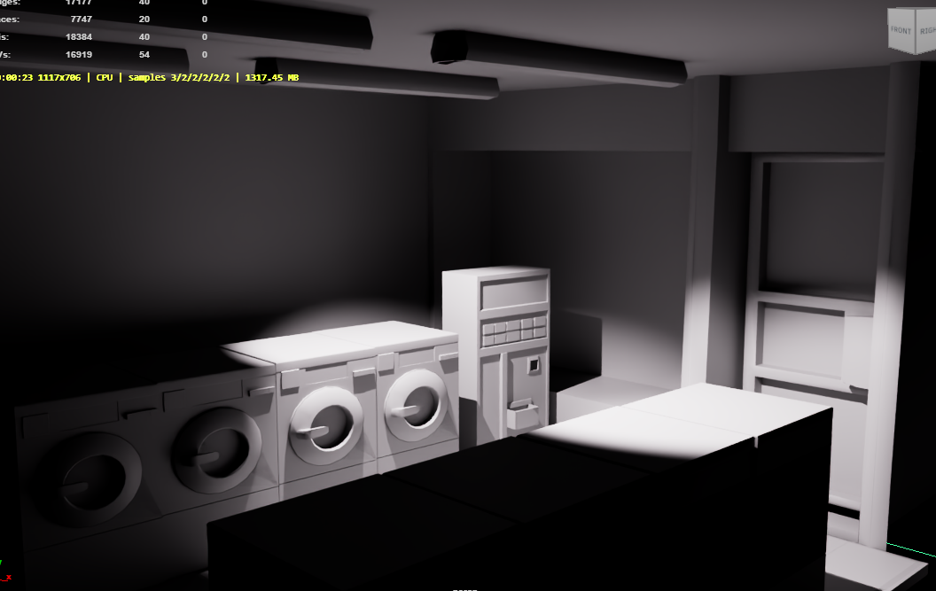
Blog post 1:
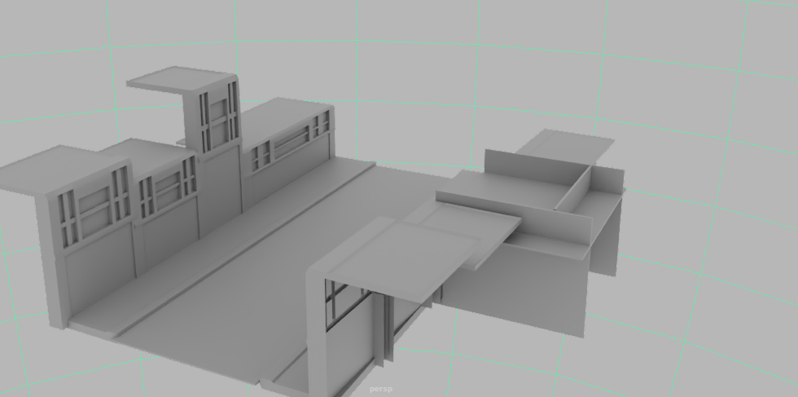
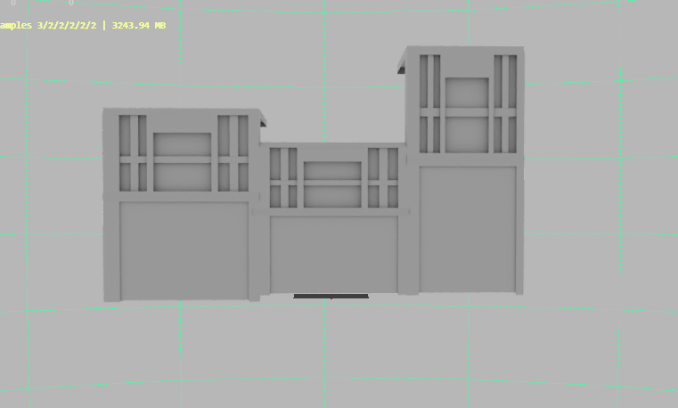
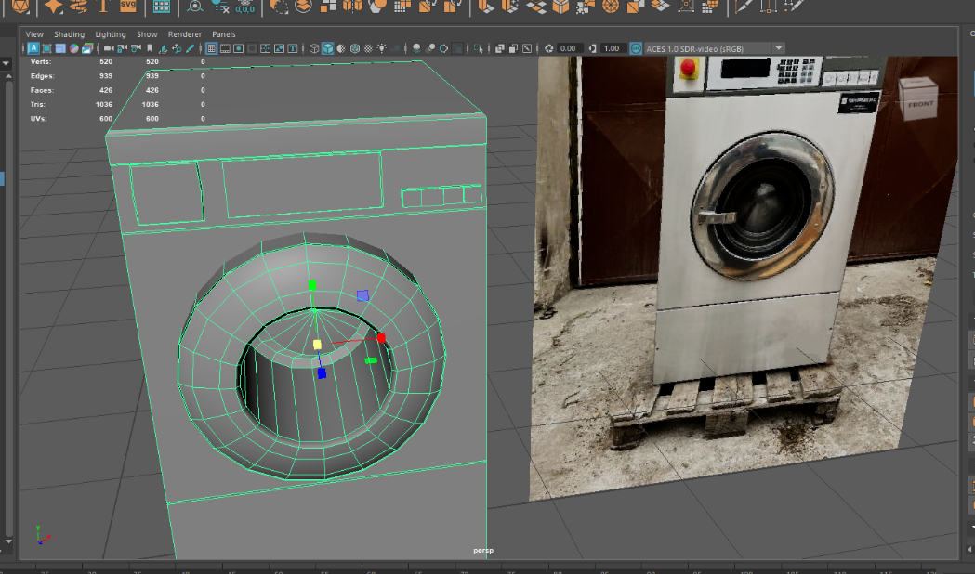
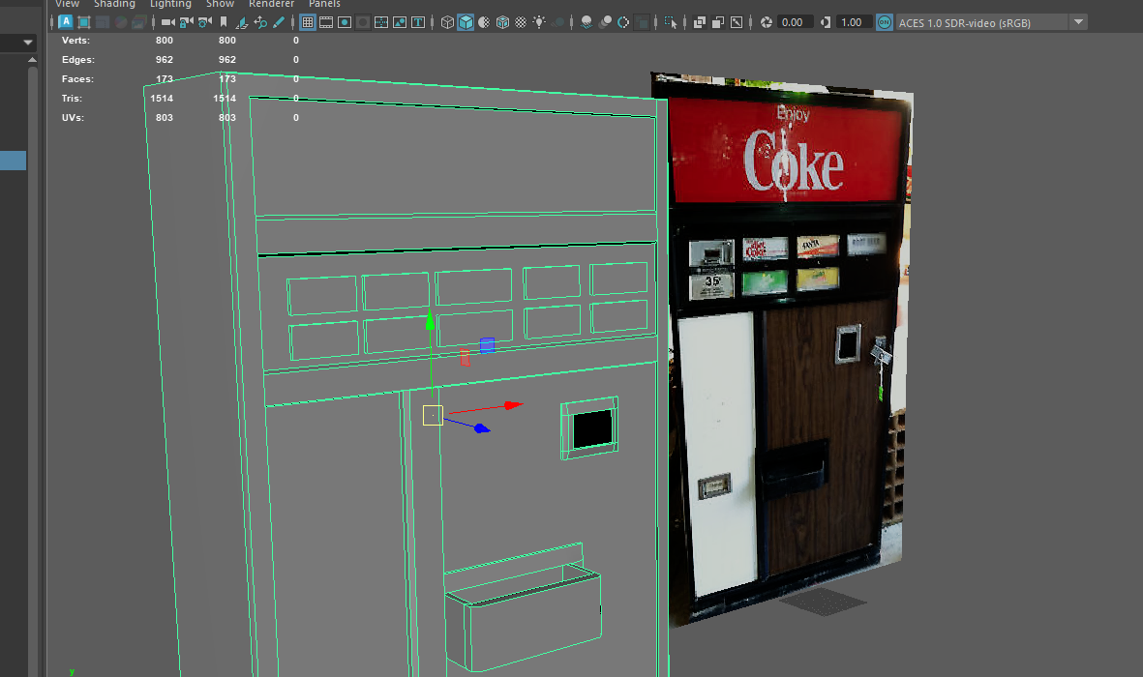
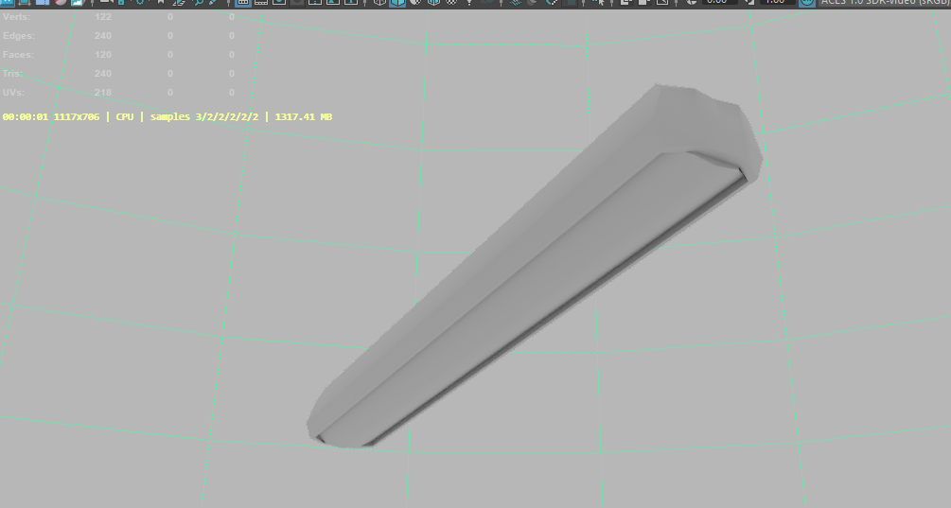
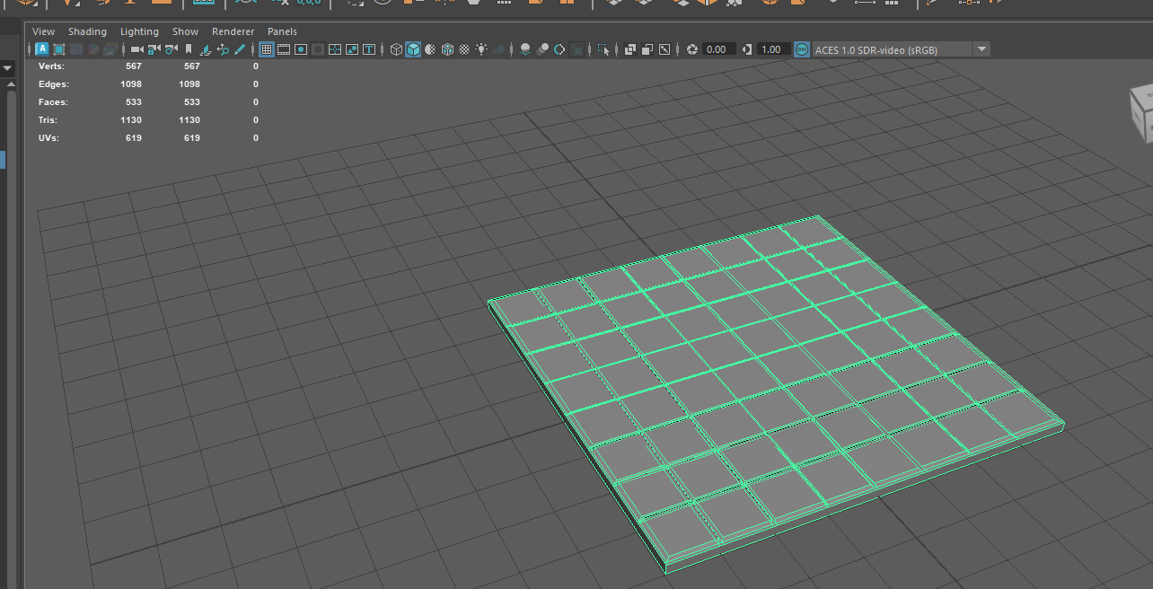
Before starting major concept and planning I first worked on a exterior area that would host a arcade machine that the player would interact with before playing the main game, in retrospect this wasn’t the best first step of development as whilst the assets wont be scrapped along with the idea it will be put up on the shelve till the game in a more proper state. The assets themselves are at a decent quality in my opinion and can serve their purpose well enough but rely heavily on texturing to have them be at an acceptable level of quality. Next steps will be to do some concept work on planning how feature will work within my jousting concept, through a swot and further exploration.

